P R E S S K I T

English.

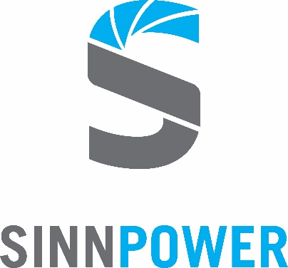

The SINN Power Story.

The Bavarian green energy startup SINN Power develops a revolutionary technology for energy harnessed from the unlimited power of our oceans.

Vision.

It is SINN Power’s vision to provide people living near coasts all over the world with access to clean electricity to enable sustainable development and contribute to our planet at the same time.

Status Quo.

Through the agile and scalable development approach, SINN Power was one of the first to build and test electricity generating systems on the sea.

Potential.

72 % of the earth’s surface is covered in oceans whose surface is constantly moving. Almost 40 % of the world’s total population live within 100 km near a coast.

Benefits.

The energy density of waves is up to 100 times more powerful compared so sun or wind. In contrast to other alternative energies, wave power is much more continuous, independently of day and night.

Worldwide energy demand.

People all over the world are desperate for climate-friendly, cost-effective alternatives to environmentally damaging diesel generators.

THE SINN POWER STORY
Worldwide innovation leader with a sustainable vision.

BACKGROUND

SINN Power was founded in 2014 and currently employs a team of 30 at its headquarters in Gauting, Germany. The green energy startup operates wave energy converter prototypes in Greece since 2015 and is currently preparing further projects to commercialize its technology.

FOUNDING HISTORY

The experienced sailor Philipp Sinn started to appreciate the power of ocean waves from an early age. After having become mechanical engineer, he was all the more surprised that there was no existing concept for economic production of electricity from ocean waves.

Lacking flexibility and high costs were the main reasons that other wave energy converters had failed. Sinn developed a concept for power generation from ocean waves that has not been considered before: A simple, cost-efficient modular concept with mass-producible standard components.

In Sinn’s dissertation on the “Comparison of a new wave power plant technology with existing power supply options at a decentralized location” he continued to develop his concept and validated it as a competitive renewable form of energy.

In 2014, SINN Power GmbH was founded with the support of Munich-based business angel Dr. Lothar Stein. Since then, Sinn and his team are working on the vision to supply people around the world with renewable energy from ocean waves.

VISION

The vision of SINN Power is to provide people all over the world with renewable energy from ocean waves and thus contribute to the sustainable development of our society and planet.
SINN Power develops revolutionary technology to turn the unlimited power of ocean waves into usable electricity, both cost-efficiently and environmentally friendly.

BUSINESS MODEL

SINN Power acts as a project developer during the current development and test phase. The company’s long-term goal is to sell the wave energy converter and other products and services as an OEM (Original Equipment Manufacturer) to project developers and contractors within the energy sector.

FUNDING AND AWARDS

SINN Power has been innovation leader in wave energy since 2014. The company is part of the Federal Government of Germany’s “6th Energy Research Program”. As a startup, SINN Power has been awarded several times for its revolutionary approach and ambitious vision to provide the world with clean energy (e.g. VDI-Preis 2015, BEE Award 2017).

PATENTS

SINN Power holds six patents and patent applications. The wave- or impulse power plant, SINN Power’s core technology, is patented since 2010. Another patent, granted in 2015, protects the proprietary linear generator and linear drive.

STATUS QUO

The agile and scalable development approach makes SINN Power one of the first developers worldwide who builds and tests power-generating systems in the sea.

SINN Power operates projects in Greece and Aruba to further develop its role as the global innovation leader and to further strengthen its establishment in the field of wave energy.

COMPANY MILESTONES

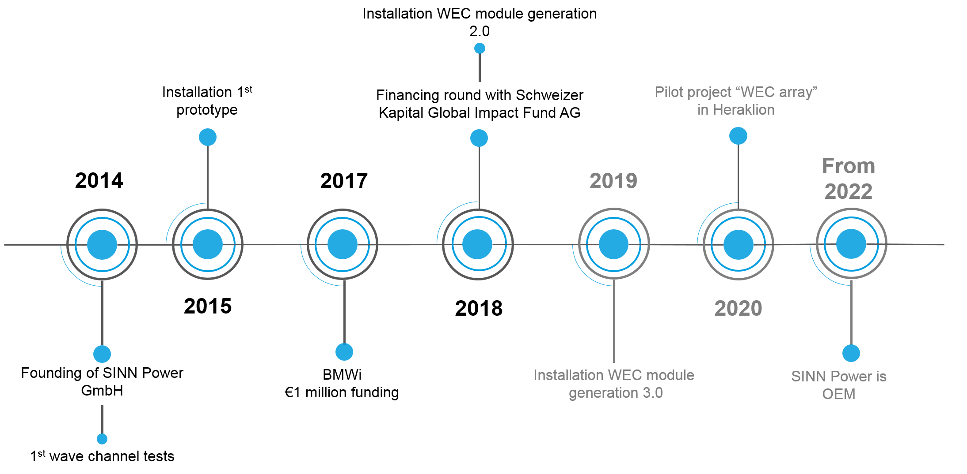

WAVE POWER
Unlimited potential – completely unexplored

POTENTIAL

The ocean, whose surface is constantly moving, covers 72 % of the earth’s total surface. The IEA estimates the usable potential of wave energy at 29,500 TWh/year – this equals 8 times Germany’s average energy consumption over a year. Furthermore, around 40 % of the world’s total population live within a 100 km radius of a coast. They all could benefit from clean ocean energy.

BENEFITS

The energy density of waves is up to 100 times more powerful compared to sun and wind. Ocean waves are more continuous, independently of day and night. Therefore, wave energy converters are significantly closer to a baseload and require less storage or other redundant systems. They also require less space and do not cause any visual or acoustic disturbances.

WORLDWIDE ENERGY DEMAND
Industrialized nations are increasingly aware of climate issues. The desire to switch to renewable energy production is rising amongst companies and private households. Climate-friendly energies are a key instrument for acting against climate change. At the same time, 6 million people in Southeast Asia alone do not have any access to electricity. Their countries’ economic development could benefit significantly from the availability of affordable ocean energy.

CHALLENGE

Previous technologies mainly failed due to the high costs of their massive installations. They also offered little flexibility, which made it impossible to meet the individual needs of customers and adapt to local wave climates.

WAVE CLIMATE
A matter of energy density and continuity

Two crucial aspects decide on the potential of a site as a location for wave energy generation: The first is energy density, which reflects in the wave height. The second is the wave continuity on the chosen location over one year. SINN Power uses rich geological databases and carries out simulations in order to advise all customers on the most suitable energy solution.

THE SINN POWER WAVE ENERGY CONVERTER

TECHNICAL PRINCIPLE

The SINN Power wave energy converter (WEC) consists of individual modules, combined and connected into one rigid structure, allowing it to float on the ocean’s surface like an anchored ship. The principle is easy: Through the up-and-down movements of the waves, the attached floating bodies of each module turn a lifting rod in motion. The result of friction: All attached generators produce electricity.

MODULARITY

The core principle of the SINN Power technology is based on modularity. WEC modules can be individually adapted to the energy demand of the customer: Varying from two dozen modules for an island community, to several hundred as a large industrial power plant.

SIMPLICITY

Because the SINN Power WEC consists of mass-producible standard components, easy transport and construction is guaranteed. All items are designed to be shipped in an ISO container, which ensures hassle-free supply to even remote coastal regions with poorly developed infrastructure. All units arrive pre-assembled, making construction on site simple and fast.

RELIABILITY

Due to its modular design and grid structure, the WEC is protected against storms and high waves. It avoids using failure-prone and environmentally harmful hydraulics by implementing a patented energy generation system.

USE CASES

In coastal areas, the SINN Power WEC supplies electricity for islands, holiday resorts and desalination plants.

Cost-efficient and low technical requirements, enable easy use and installation, especially in countries that may have less developed infrastructure.

In offshore areas, WECs feed into the grid in combination with offshore wind turbines. Oil platforms and harbors are other possible applications for the SINN Power technology.

USE CASE: SINN Power SINGLE WEC MODULE

Single WEC modules can be easily mounted to an existing structure or harbor wall. Depending on the individual energy demand, the number of modules can be adapted accordingly to reach the desired energy output.
This application is especially beneficial to offshore structure operators (e.g. offshore platforms or pumping stations, offshore wind farms, aquaculture and fish farms and offshore marine research stations or harbors).

USE CASE: SINN POWER WEC IN HYBRID-ENERGY SYSTEMS

The SINN Power WEC is the perfect basis for a sustainable energy system for customers wo are not connected to the public power grid. If needed, the company designs customized hybrid energy solutions: A combination of wave energy, small hydropower, small wind power, photovoltaic and storage solutions offers a secure, affordable and clean energy supply.
SINN Power also offers the necessary complex, high-tech components that ensure technical compatibility throughout the whole energy system.

THE SINN POWERTRAIN
SINN Power mechatronics – state-of-art technology combined with robust housing

The SINN PowerTrain: Integrated power electronics and control system

Decentralizing energy generation is a powerful strategy for a sustainable energy transition. As a result, a growing number of companies ae working on planning, developing and selling decentralized energy systems and solutions.

Based on years of intense R&D, SINN Power realized that there was no existing energy-generating device that was suitable for the harsh maritime environment. Since the generators play such a key role in SINN Power’s WEC modules, the startup developed its own generator with integrated power electronics.

ONE DEVICE: A combination of state-of-art technology and robust coating

Optimized for the ocean energy industry, the SINN PowerTrain is IP 68-rated, compact, lightweight and fully integrable with existing energy systems. It is a versatile high-tech linear generator featuring integrated power electronics, customizable gear ratios, a permanent magnet-synchronous electrical machine and a mechanical brake as well as an AC/DC converter.
The machine is safely stored in an IP 68-sealed aluminium cast that protects all integrated modules from any water and dust exposure.

USE CASES: Combining several renewable energy sources into one system

With a rated power of 3 kW, the PowerTrain is universally applicable and customizable for various applications. In addition to its application in wave energy converters, the device is also highly suitable for horizontal and vertical small wind turbines and hydropower plants or other small-scale energy systems. The PowerTrain can also act as a starter and controller in diesel gensets that act as backup for the renewable systems.

The SINN PowerTrain offers a wide range of possible applications for energy production. It optimizes the energy generation of individual systems. And it increases the mutual compatibility of various renewable energy sources.

ADVANTAGES

The use of the SINN PowerTrain makes it possible to connect several small wind turbines in parallel. The integrated power electronics ensure an equal output current across all systems. This means that a large number of systems can feed into the grid with one inverter, making several inverters redundant and allow cost savings.

As a controller and starter for small diesel gensets, the PowerTrain dynamically adjusts their running speed based on the current energy demand. First research has shown that this enables a reduction of diesel fuel usage of up to 30 %. A dynamic control system ensures that only the minimum number of generators run at the same time.

SINN POWER PROJECTS

HERAKLION

Since 2015, SINN Power has been testing prototypes of its wave energy converter at the breakwater wall of Heraklion on the Greek island of Crete. As one of the first developers worldwide, in July 2018 SINN Power succeeded to produce feed-in electricity.
Ongoing long-term tests enable continuous optimizations in mechanical, control engineering and electrical engineering. The next prototype generation with further revised technology will complete its installation in summer 2019.

The research and development work in Heraklion started in 2017, when the Federal Ministry of Economic Affairs and Energy (BMWi) granted a funding of € 1.0m as part of the 6th Energy Research Program. This allows SINN Power to develop the technology to market maturity until the project is completed.
ARUBA

In 2018, SINN Power took part in the first German-Caribbean Energy Conference and was able to establish first contacts with energy representatives of the Caribbean islands Aruba, Bonaire and Curacao.

Aruba, with its affiliation to the Dutch kingdom is a sustainable location for a SINN Power pilot project from both, a political and an economic perspective. SINN Power was able to establish relationships with local representatives and is in close contact with WEBAruba. A follow-up trip, organized and supported by the German-Dutch chambers of commerce to discuss the next steps for a pilot wave energy project on Aruba is currently in preparation for the end of 2019.

PARTNERS AND SUPPORTERS

SINN Power is supported by a high-profile international stakeholder network of investors, mentors, universities and public R&D facilities. All supporters are linked on our website under the shortcut “Partners”.

CONTACT US

Press contact Jana Funk
Contact details jana.funk@sinnpower.com
+49 (0)89 925 661 92

www.sinnpower.com

SINN Power GmbH
Germeringer Str. 9
82131 Gauting
Germany

PRESS MEDIA

SINN Power media material will be available to download from our website soon!
Please get in touch with Jana Funk.

FIND US ON SOCIAL MEDIA

LinkedIn
Facebook
Instagram
Twitter
Youtube

